 | EUROPEAN COMMISSION  DIRECTORATE-GENERAL  INFORMATICS  Information systems Directorate

European Commission
e-Trustex Use Case Specification: Submit Document Archive Request

Date: | 21/04/2016
Version: | 0.005
Authors: | Yves.ADAM@ext.ec.europa.eu
Revised by: | Technical Review: CHIRIAC Cristian  Quality Review:
Approved by:
Public:
Reference Number:

TABLE OF CONTENTS
1. Use-Case Description 3
2. References 4
3. Points of Extensions 5
3.1. Points of extension mapping 5
3.1.1. Pragraphes by extension point 5
3.1.2. Extension points by paragraphes 5
3.2. Document Type Code 6
3.3. Party Roles 6
3.4. Document Identifier 6
3.5. Document Issue Date 6
3.6. Synchronous XSD Validation 6
3.7. Synchronous Schematron Validation 6
3.8. Synchronous Specific Validation 7
3.8.1. Synchronous SLA Validation 7
3.8.2. Other specific validation 7
3.9. Synchronous Business Specific Processing 7
3.10. Asynchronous XSD Validation 7
3.11. Asynchronous Business Rules Validation 7
3.11.1. Asynchronous Schematron Validation 7
3.11.2. Asynchronous Parent-Child Relationship Validation 7
3.11.3. Reprocessing Timeframe for Parent Document 7
3.11.4. Asynchronous Specific Validation 7
3.12. Asynchronous Business Specific Processing 7
3.12.1. Human Readable Generation 7
3.12.2. SLA Policy Validation 8
3.12.3. Other specific processing 8
3.12.3.1. Sub-Use case - Basic flow 8
3.12.3.2. Alternative flows 9
3.12.3.3. Exceptional flows 9
3.13. Availability Notification 10
3.14. State Machine 11
3.14.1. Transition to Received 11
3.14.2. Transition to Error 11
3.14.3. Transition to state Archived 11
3.14.4. Transition to state Failed 11
3.15. Dispatching 12
4. Additional Information 13
4.1. Specific Exceptions 13
4.2. ArchiveRequest XSD 13
4.3. Drawings 14

Document History

Version | Date | Comment | Modified Pages
0.001 | 7/3/2016 | Creation | n/a
0.002 | 18/3/2016 | Updates after review by Cristian CHIRIAC
0.003 | 21/3/2016 | Updates after review by Cristian CHIRIAC
0.004 | 14/4/2016 | Updates after review by Cristian CHIRIAC
0.005 | 21/4/2016 | Updates after review by Cristian CHIRIAC

Use-Case Description
This Use Case describes the service that enables parties to archive any type of Document into an Archiving System by issuing an ArchiveDocumentRequest to e-TRUSTEX.
It implements the Submit Document Template that extends the generic use case UC1_002 Process Asynchronous Message to ArchiveDocumentRequest.

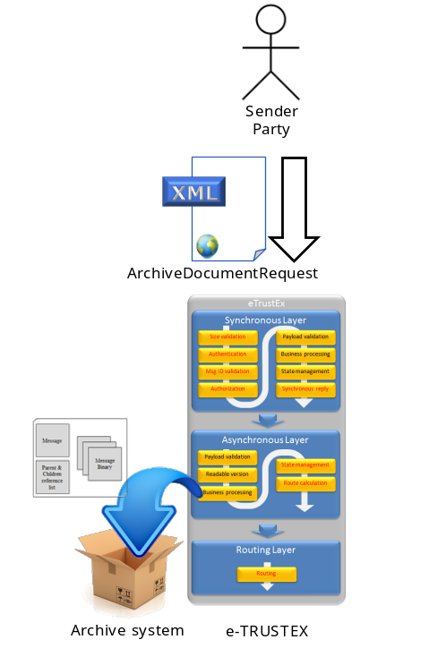
Major operations:

- The sender sends an ArchiveDocumentRequest to e-TRUSTEX specifying a document to be archived.

- The business processing step of the asynchronous layer directly interacts with the archiving system to store the specified document (it does not go through the standard routing layer).

- Optionaly (i.e. if specified as such in the request) the same operation is applied recursively to all descendants of the message (as defined by the parent/child relationship between messages).

Note: the 'destination' system being the archive system, there is no message routed to or made available to any Receiver Party.

References
Document Title | Document Reference
Submit Document Template | Version 2.005 of https://webgate.ec.europa.eu/CITnet/svn/ETRUSTEX/trunk/001%20e-TrustEx/002%20Requirements/Use%20Case%20Model/New%20Use%20Cases/Submit%20Document%20Template%20Use%20Case%20Specification_2.0.doc
UC1_002 Process Asynchronous Message | https://webgate.ec.europa.eu/CITnet/svn/ETRUSTEX/trunk/001%20e-TrustEx/002%20Requirements/Use%20Case%20Model/New%20Use%20Cases/UC1_002%20Process%20Asynchronous%20Message.doc
Code List Document | https://webgate.ec.europa.eu/CITnet/svn/ETRUSTEX/trunk/001 e-TrustEx/003 Architecture/001 Data Model/000 Code Tables/EC_CodeList_e-TrustEx.xls
ArchiveDocumentRequest XSD Document | https://webgate.ec.europa.eu/CITnet/svn/ETRUSTEX/trunk/001 e-TrustEx/004 Development/001 Implementation/e-TrustEx/etrustex-core-web/src/main/webapp/xsd/maindoc/EC-ArchiveDocumentRequest-1.0.xsd
ArchiveDocumentRequest WSDL Document | https://webgate.ec.europa.eu/CITnet/svn/ETRUSTEX/trunk/001 e-TrustEx/004 Development/001 Implementation/e-TrustEx/etrustex-core-web/src/main/webapp/wsdl/ArchiveDocumentRequest-1.0.wsdl
ArchiveDocumentResponse  XSD Document | https://webgate.ec.europa.eu/CITnet/svn/ETRUSTEX/trunk/001 e-TrustEx/004 Development/001 Implementation/e-TrustEx/etrustex-core-web/src/main/webapp/xsd/maindoc/ EC-ArchiveDocumentResponse-1.0.xsd

Points of Extensions

Points of extension mapping

Pragraphes by extension point
Extended point (in Asynchronous Use Case) | Point of extension (in this document)
Point of extension 1 | Party Roles
Point of extension 2 | Document Type Code
Point of extension 3 | Document Identifier
Point of extension 4 | Document Type Code
Point of extension 5 | Synchronous XSD Validation (N/A)
Point of extension 6 | Synchronous Schematron Validation (N/A)
Point of extension 7 | Synchronous Specific Validation (N/A)
Point of extension 8 | Document Issue Date
Point of extension 9 | Document Type Code
Point of extension 10 | Asynchronous XSD Validation
Point of extension 11 | Asynchronous Schematron Validation (N/A)
Point of extension 12 | Asynchronous Parent-Child Relationship Validation
Point of extension 13 | Data Extraction (N/A)
Point of extension 14 | Asynchronous Business Specific Processing
Point of extension 15 | Dispatching (N/A)
Point of extension 16 | Reprocessing Timeframe (N/A)
Point of extension 17 | Synchronous Business Specific Processing (N/A)
Point of extension 18 | Asynchronous Specific Validation (N/A)
Point of extension 19 | Availability Notification (N/A)

Extension points by paragraphes
Point of extension (in this document) | Extended point (in Asynchronous Use Case)
Document Type Code | Point of extension 2  Point of extension 4  Point of extension 9
Party Roles | Point of extension 1
Document Identifier | Point of extension 3
Document Issue Date | Point of extension 8
Synchronous XSD Validation | Point of extension 5
Synchronous Schematron Validation | Point of extension 6
Synchronous Specific Validation | Point of extension 7
Synchronous Business Specific Processing | Point of extension 17
Asynchronous XSD Validation | Point of extension 10
Asynchronous Schematron Validation | Point of extension 11
Asynchronous Parent-Child Relationship Validation | Point of extension 12
Reprocessing Timeframe | Point of extension 16
Asynchronous Specific Validation | Point of extension 18
Data Extraction | Point of extension 13
Asynchronous Business Specific Processing | Point of extension 14
Availability Notification | Point of extension 19
Dispatching | Point of extension 15

Document Type Code
The document type code for ArchiveDocumentRequest is ARQ and it is defined in Code List Document, under the sheet DocumentTypeCode.

Party Roles
The ArchiveDocumentRequest document must be sent by a Party having Any Role.
The 'pseudo' receiver being the system itself as intermediate with the archive system, the 'receiving' Party Role is not applicable).

Document Identifier
The document identifier can be found via the following Xpath expression:
\\ArchiveDocumentRequest\cbc:ID

Document Issue Date
The document issue date can be found via the following Xpath expression:
\\ArchiveDocumentRequest\cbc:IssueDate

Synchronous XSD Validation
N/A

Synchronous Schematron Validation
N/A

Synchronous Specific Validation

Synchronous SLA Validation
N/A

Other specific validation
N/A

Synchronous Business Specific Processing
N/A

Asynchronous XSD Validation
- The request document must be valid according to the ArchiveDocumentRequest XSD Document.

Asynchronous Business Rules Validation

Asynchronous Schematron Validation
N/A

Asynchronous Parent-Child Relationship Validation
The document to be archived must previously exist: the system verifies its presence in the database based on its idenfier. This document unique identifier is composite, and based on the same type of fields than the identifier of the archive request. These values can be extracted from the XML according to the following XPathes:
- \\ArchiveDocumentRequest\cac:SenderParty\PartyIdentification\cbc:ID
Note: only the sender or the receiver of a document can ask to archive one of his document, therefore, the SenderParty and the ReceiverParty of the archive request document is used to identify the document to archive.
- \\ArchiveDocumentRequest\cac:ReceiverParty\PartyIdentification\cbc:ID
- \\ArchiveDocumentRequest\cac:DocumentReference\cbc:DocumentTypeCode
- \\ArchiveDocumentRequest\cac:DocumentReference\cbc:ID

Note: in case of recursive archiving, no further checking is required at this stage since the parent/child relationship is enforced by the database itself.

Reprocessing Timeframe for Parent Document
N/A.

Asynchronous Specific Validation
N/A.

Asynchronous Business Specific Processing

Human Readable Generation
N/A.

SLA Policy Validation
N/A.

Other specific processing

Sub-Use case - Basic flow
Summary
Upon such request, the system will extract the message content from the database, put it into some structure and request the archive system to store this structure.
This operation is applied on the specified message and recursively on all its descendants, as defined by the parent/child relationship between messages.
As the archive solution is not defined at the moment of the redaction of this use case, it is not yet known if this one will operate synchronously or asynchronously.
In case of temporary unavailability of the archive system, the generic retry mechanism is used.
In case of definitive error specified by the archive system, or the mximum number of retries has been reached, the system sends back and error to the requester in an "Application Response" message.
Details
- The system connect to the archive system (if applicable)
- The system converts the message into some structure (to be defined in the detailed desing) that will hold the data from the tables holding the message content:
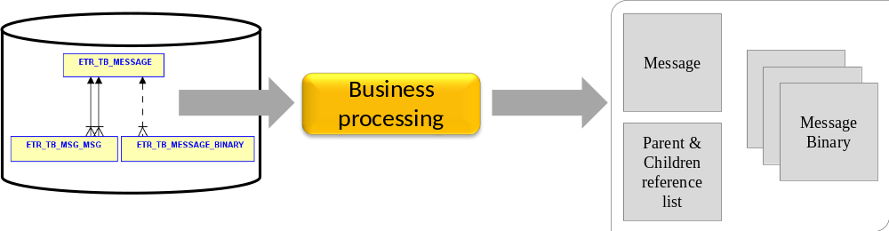
Note: The "Parent and Children list" must refer to the actual business unique identifiers of the referenced messages (no internal technical identifier).
- The systems sends the document to be archived to the archive system providing:
  - The business unique identifier of the archived message as identifier for future retrieval (if the information is too large as identifier, a mapping will be used and stored into the database between the business 'large' identifier, and a shorter one – e.g. a number from a sequence);
  - A number defining the version of the structure format used to store the content of the message (allowing the structure to evolve over time in the archives without conversion);
  - The structure holding the message content as defined above.
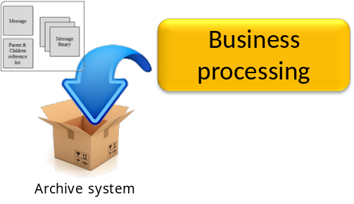
- The systems receives the confirmation of the archive system of the completion of the operation
Note: If some document is mentioned by the archiving system as "already present", the system does NOT end up in error (since the current operation may occure has result of a previous one that did not end-up completely).
- IF…
  - the message has some children, and
  - the flag ' RecursiveArchive' in the DocumentArchiveRequest requires this recursive action;
THEN…
  - the systems 'remembers' the current archived document for further processing as from step 3;
  - the archive operation is repeated recursively onto all its descendents from step 2 to step 5.

- The system returns the DocumentArchiveResponse to the sender.
This response refers to the parent document of all archived documents (only the parent one, not all its descendents if recursive processing was done).

This processing is described in use case "Archive Document Response".

Alternative flows
N/A

Exceptional flows

At step 1, connection fails
- The generic processing is used in suche case: eTrustEx will retry several time with a configurable delay between retries. If the number of retries is execeeded, proceed to step 6 with an "ApplicationResponse" to the sender containing a description of the error.
- Sub-use case ends.

At step 3 archive fails with a definitive error
"Definitive error" means that further retry would be useless because it would fail also (e.g. request is not well formed, message is too large,…)
- Proceed to step 6 with an "ApplicationResponse" to the sender containing a description of the error.
- Sub-use case ends.

At step 3, archive fails with a temporary error
"Temporary error" means that later retry could lead to success (e.g. archive system not reachable, temporarily out of service …)
- The generic processing is used in such case: eTrustEx will retry several time with a configurable delay between retries. If the number of retries is execeeded, proceed to step 6 with an "ApplicationResponse" to the sender containing a description of the error.
- Sub-use case ends.

Availability Notification
N/A

State Machine
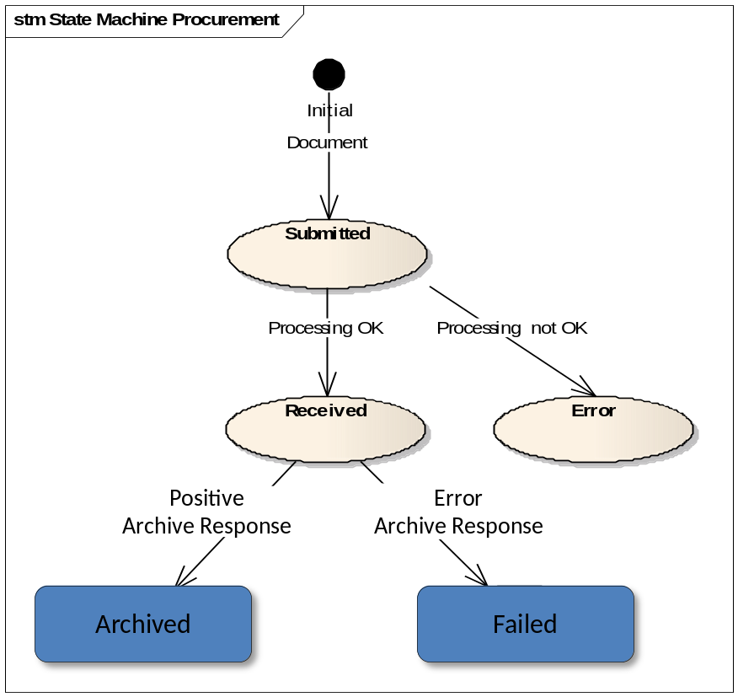
The archiving being controlled from the system itself, and processed by an integrated archive system, in the present case, there is no real "receiver application" per say.

Transition to Received
If asynchronous processing succeeds.

Transition to Error
If asynchronous processing fails.

Transition to state Archived
If no error occured during the processing in the archiving system.
The 'ArchiveDocumentResponse' contains an 'ArchiveDocumentPositiveResponse'.

Transition to state Failed
In case any error occurs during the processing in the archiving system.
The 'ArchiveDocumentResponse' contains an 'ArchiveDocumentErrorResponse'.

Dispatching
N/A. The archiving being controlled from the system itself, and processed by an integrated archive system, in the present case, there is no real "receiver application" per say, and consequently no dispatching.
Instead, the system puts the ArchiveDocumentResponse in the DocumentQueue in order to process this one as if the message was issued by eTrustEX. Further detailed information is available in UC1_015 Submit Document Archive Response.

Additional Information

Specific Exceptions
All specific exceptions are detailed under 3.12.3.3- "Exceptional flows".

ArchiveRequest XSD
<?xml version="1.0" encoding="UTF-8"?>
<xsd:schema xmlns="ec:schema:xsd:ArchiveDocumentRequest-1" xmlns:ext="urn:oasis:names:specification:ubl:schema:xsd:CommonExtensionComponents-2" xmlns:cbc="urn:oasis:names:specification:ubl:schema:xsd:CommonBasicComponents-2" xmlns:cac="urn:oasis:names:specification:ubl:schema:xsd:CommonAggregateComponents-2" xmlns:xsd="http://www.w3.org/2001/XMLSchema" xmlns:ccts="urn:un:unece:uncefact:documentation:2" targetNamespace="ec:schema:xsd:ArchiveDocumentRequest-1" elementFormDefault="qualified" attributeFormDefault="unqualified" version="1.0">
<!-- ===== Imports ===== -->
<xsd:import namespace="urn:oasis:names:specification:ubl:schema:xsd:CommonAggregateComponents-2" schemaLocation="../common/UBL-CommonAggregateComponents-2.0.xsd"/>
<xsd:import namespace="urn:oasis:names:specification:ubl:schema:xsd:CommonBasicComponents-2" schemaLocation="../common/UBL-CommonBasicComponents-2.0.xsd"/>
<xsd:import namespace="urn:oasis:names:specification:ubl:schema:xsd:CommonExtensionComponents-2" schemaLocation="../common/UBL-CommonExtensionComponents-2.0.xsd"/>
<!-- ===== Root Element ===== -->
<xsd:element name="ArchiveDocumentRequest" type="ArchiveDocumentRequestType"/>
<xsd:complexType name="ArchiveDocumentRequestType">
<xsd:sequence>
<xsd:element ref="ext:UBLExtensions" minOccurs="0"/>
<xsd:element ref="cbc:UBLVersionID" minOccurs="0"/>
<xsd:element ref="cbc:CustomizationID" minOccurs="0"/>
<xsd:element ref="cbc:ProfileID" minOccurs="0"/>
<xsd:element ref="cbc:ID"/>
<xsd:element ref="cbc:UUID" minOccurs="0">
<xsd:annotation>
<xsd:documentation>
<ccts:Component>
<ccts:ComponentType>BBIE</ccts:ComponentType>
<ccts:DictionaryEntryName>Attached Document. UUID. Identifier</ccts:DictionaryEntryName>
<ccts:Definition>A universally unique identifier for an instance of this ABIE.</ccts:Definition>
<ccts:Cardinality>0..1</ccts:Cardinality>
<ccts:ObjectClass>Attached Document</ccts:ObjectClass>
<ccts:PropertyTerm>UUID</ccts:PropertyTerm>
<ccts:RepresentationTerm>Identifier</ccts:RepresentationTerm>
<ccts:DataType>Identifier. Type</ccts:DataType>
</ccts:Component>
</xsd:documentation>
</xsd:annotation>
</xsd:element>
<xsd:element ref="cbc:IssueDate" minOccurs="0"/>
<xsd:element ref="cbc:IssueTime" minOccurs="0">
<xsd:annotation>
<xsd:documentation>
<ccts:Component>
<ccts:ComponentType>BBIE</ccts:ComponentType>
<ccts:DictionaryEntryName>Attached Document. Issue Time. Time</ccts:DictionaryEntryName>
<ccts:Definition>A time denoting when the Attached Document was issued.</ccts:Definition>
<ccts:Cardinality>0..1</ccts:Cardinality>
<ccts:ObjectClass>Attached Document</ccts:ObjectClass>
<ccts:PropertyTerm>Issue Time</ccts:PropertyTerm>
<ccts:RepresentationTerm>Time</ccts:RepresentationTerm>
<ccts:DataType>Time. Type</ccts:DataType>
</ccts:Component>
</xsd:documentation>
</xsd:annotation>
</xsd:element>
<xsd:element ref="cbc:Note" minOccurs="0" maxOccurs="unbounded">
<xsd:annotation>
<xsd:documentation>
<ccts:Component>
<ccts:ComponentType>BBIE</ccts:ComponentType>
<ccts:DictionaryEntryName>Attached Document. Note. Text</ccts:DictionaryEntryName>
<ccts:Definition>Contains any free-form text pertinent to the entire document or to the document message itself. This element may contain notes or any other similar information that is not contained explicitly in another structure.</ccts:Definition>
<ccts:Cardinality>0..n</ccts:Cardinality>
<ccts:ObjectClass>Attached Document</ccts:ObjectClass>
<ccts:PropertyTerm>Note</ccts:PropertyTerm>
<ccts:RepresentationTerm>Text</ccts:RepresentationTerm>
<ccts:DataType>Text. Type</ccts:DataType>
</ccts:Component>
</xsd:documentation>
</xsd:annotation>
</xsd:element>
<xsd:element ref="cac:Signature" minOccurs="0" maxOccurs="unbounded">
<xsd:annotation>
<xsd:documentation>
<ccts:Component>
<ccts:ComponentType>ASBIE</ccts:ComponentType>
<ccts:DictionaryEntryName>Attached Document. Signature</ccts:DictionaryEntryName>
<ccts:Definition>Associates the Attached Document with zero or more signatures.</ccts:Definition>
<ccts:Cardinality>0..n</ccts:Cardinality>
<ccts:ObjectClass>Attached Document</ccts:ObjectClass>
<ccts:PropertyTerm>Signature</ccts:PropertyTerm>
<ccts:AssociatedObjectClass>Signature</ccts:AssociatedObjectClass>
</ccts:Component>
</xsd:documentation>
</xsd:annotation>
</xsd:element>
<xsd:element ref="cac:SenderParty" minOccurs="0">
<xsd:annotation>
<xsd:documentation>
<ccts:Component>
<ccts:ComponentType>ASBIE</ccts:ComponentType>
<ccts:DictionaryEntryName>Document Status Request. Sender_ Party. Party</ccts:DictionaryEntryName>
<ccts:Definition>An association to the Party sending this document.</ccts:Definition>
<ccts:Cardinality>0..1</ccts:Cardinality>
<ccts:ObjectClass>Document Status Request</ccts:ObjectClass>
<ccts:PropertyTermQualifier>Sender</ccts:PropertyTermQualifier>
<ccts:PropertyTerm>Party</ccts:PropertyTerm>
<ccts:AssociatedObjectClass>Party</ccts:AssociatedObjectClass>
</ccts:Component>
</xsd:documentation>
</xsd:annotation>
</xsd:element>
<xsd:element ref="cac:ReceiverParty" minOccurs="0">
<xsd:annotation>
<xsd:documentation>
<ccts:Component>
<ccts:ComponentType>ASBIE</ccts:ComponentType>
<ccts:DictionaryEntryName>Document Status Request. Receiver_ Party. Party</ccts:DictionaryEntryName>
<ccts:Definition>An association to the Party receiving this document.</ccts:Definition>
<ccts:Cardinality>0..1</ccts:Cardinality>
<ccts:ObjectClass>Document Status Request</ccts:ObjectClass>
<ccts:PropertyTermQualifier>Receiver</ccts:PropertyTermQualifier>
<ccts:PropertyTerm>Party</ccts:PropertyTerm>
<ccts:AssociatedObjectClass>Party</ccts:AssociatedObjectClass>
</ccts:Component>
</xsd:documentation>
</xsd:annotation>
</xsd:element>
<xsd:element ref="cac:DocumentReference"/>
<xsd:element name="RecursiveArchive" default="false" minOccurs="0"/>
</xsd:sequence>
</xsd:complexType>
</xsd:schema>

Drawings
The attached powerpoint contains the drawings included in this document to make them available for later updates: 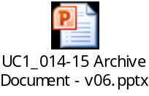

CreateDocumentRequest Information Mapping
CreateDocumentRequest element | Information | From
createDocument/Header | Mandatory element. Can be empty.
createDocument/Header/MessageContext/Id | UUID generated by eTrustEx to track the request execution | System generated
createDocument/Header/MessageContext/Timestamp | UTC time of the request | System generated
createDocument/Header/SecurityContext/SystemId | System's name | "eTrustEx"
createDocument/Header/SecurityContext/EcasDomain | Not used. | -
createDocument/Header/SecurityContext/EcasUserId | Not used. | -
createDocument/Header/SecurityContext/OnBehalfOfSystemId | To be used when the application sending the request is not the one that has originally requested the operation (so when eTrustEx service Document Archive Request is called). | The business domain of the issuer of Document Archive Request
createDocument/Header/ResultSetContext/StatelessPagination/PageSize | Not used. | -
createDocument/Header/ResultSetContext/StatelessPagination/PageNumberStartingFromZero | Not used. | -
createDocument/DocumentType | To be used only when the issuer of Document wants to specify the CCM2 document type. In this case only the ID child will be used.  If not specified, the default ERIS document type will be used. The metadata specific to this document and its parents can be configured via another element.
createDocument/DocumentType/Id | The Id of the CCM2 document type. Mandatory when element DocumentType or DocumentType/Id is present.
createDocument/DocumentType/Abbreviation | Not used
createDocument/DocumentType/ClassId | Not used
createDocument/DocumentType/Context | Not used
createDocument/DocumentType/Description | Not used
createDocument/Metadata | Mandatory element. To be used if the issuer of the document wants to specify CCM2 metadata. In this case the DocumentMetaData element will be used for each metadata, having the CCM2 metadata id specified under MetaDataRef/Id and its value under Value/<MetaDataType>/Value, where <MetaDataType> can be String, Date, Boolean, Integer or Decimal.
createDocument/Metadata/DocumentMetaData(i)/MetaDataRef/Id | The CCM2 id of the document metadata.
createDocument/Metadata/DocumentMetaData(i)/MetaDataRef/Abbreviation | Not used
createDocument/Metadata/DocumentMetaData(i)/MetaDataRef/ClassId | Not used
createDocument/Metadata/DocumentMetaData(i)/MetaDataRef/Context | Not used
createDocument/Metadata/DocumentMetaData(i)/MetaDataRef/Description | Not used
createDocument/Metadata/DocumentMetaData(i)/Value | The metadata value under the value element of the metadata type child.
createDocument/SendersRecipients

